Filed by Portman Ridge Finance Corporation

pursuant to Rule 425 under the Securities Act of 1933
Subject Company: Logan Ridge Finance Corporation
Commission File No. 814-01022

File No. of Related Registration Statement: 333-285230
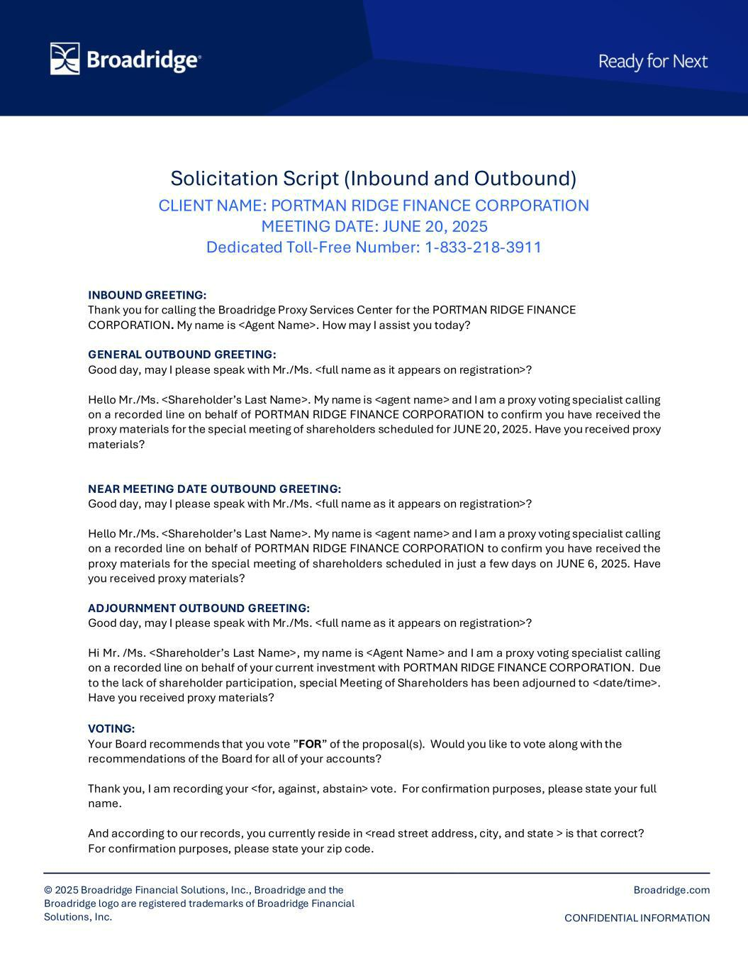



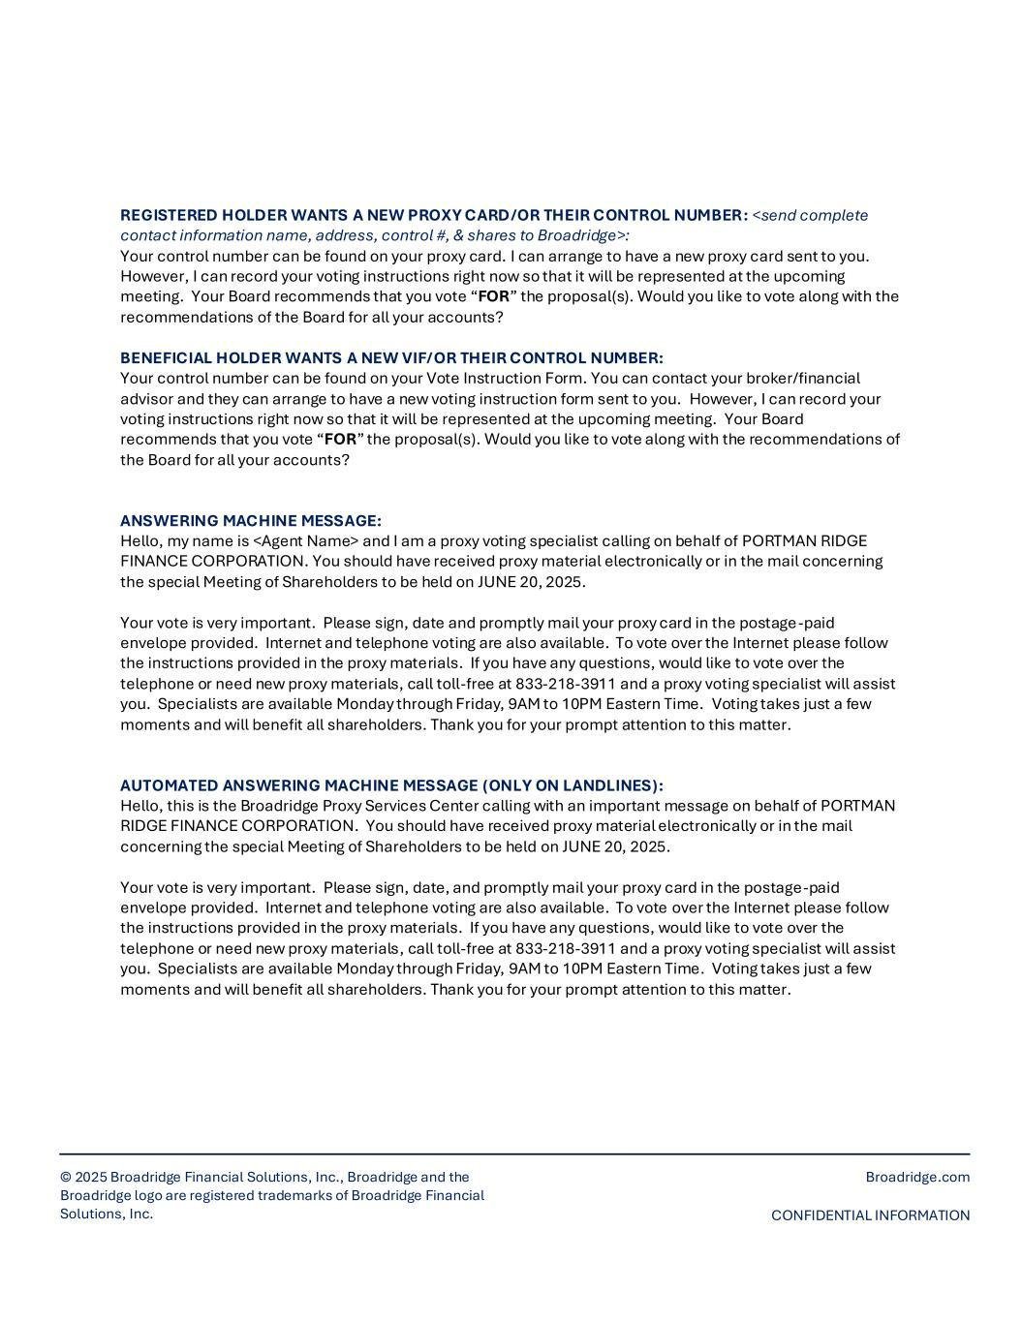

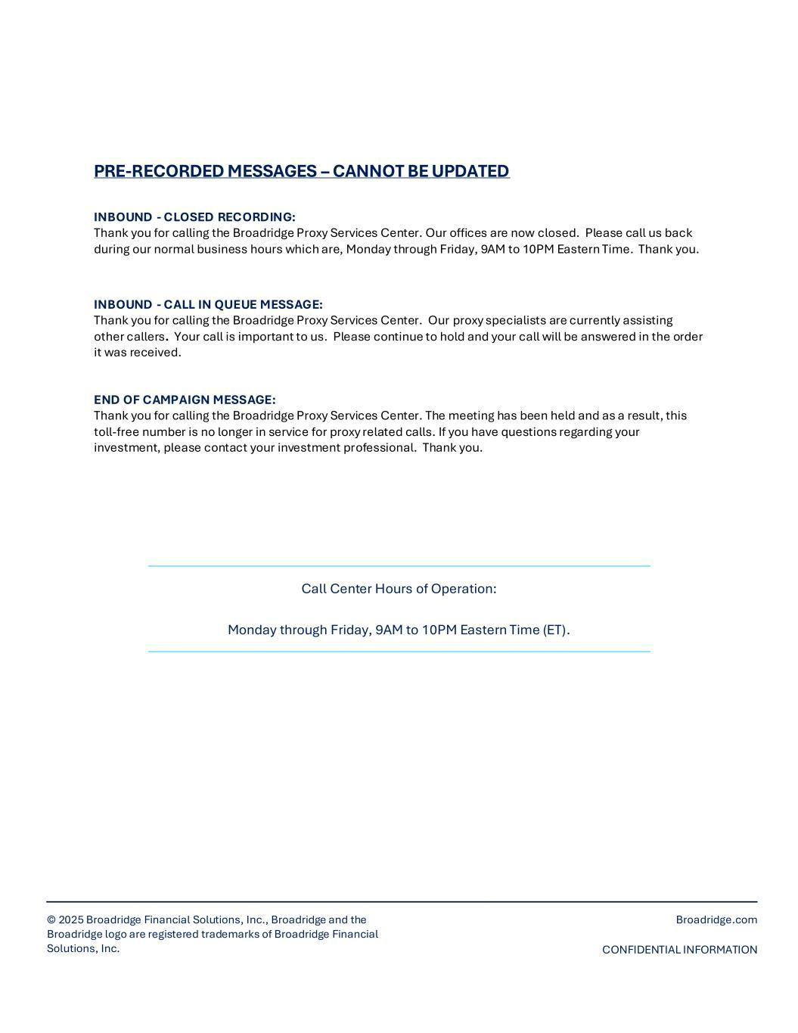

Cautionary Statement Regarding Forward-Looking Statements

Some of the statements in this communication constitute forward-looking statements because they relate to future events, future performance or financial condition. The forward-looking statements may include statements as to future operating results of PTMN and LRFC, and distribution projections; business prospects of PTMN and LRFC, and the prospects of their portfolio companies; and the impact of the investments that PTMN and LRFC expect to make. In addition, words such as “anticipate,” “believe,” “expect,” “seek,” “plan,” “should,” “estimate,” “project” and “intend” indicate forward-looking statements, although not all forward-looking statements include these words. The forward-looking statements contained in this communication involve risks and uncertainties. Certain factors could cause actual results and conditions to differ materially from those projected, including the uncertainties associated with (i) the ability of the parties to consummate the merger on the expected timeline, or at all; (ii) the expected synergies and savings associated with the merger; (iii) the ability to realize the anticipated benefits of the merger, including the expected elimination of certain expenses and costs due to the merger; (iv) the percentage of PTMN shareholders and LRFC shareholders voting in favor of the applicable Proposal (as defined below) submitted for their approval;

- the possibility that competing offers or acquisition proposals will be made; (vi) the possibility that any or all of the various conditions to the consummation of the merger may not be satisfied or waived; (vii) risks related to diverting management’s attention from ongoing business operations; (viii) the combined company’s plans, expectations, objectives and intentions, as a result of the merger; (ix) any potential termination of the merger agreement; (x) the future operating results and net investment income projections of PTMN, LRFC or, following the closing of the merger, the combined company; (xi) the ability of Sierra Crest Investment Management LLC (“Sierra Crest”) to implement its future plans with respect to the combined company; (xii) the ability of Sierra Crest and its affiliates to attract and retain highly talented professionals; (xiii) the business prospects of PTMN, LRFC or, following the closing of the merger, the combined company, and the prospects of their portfolio companies; (xiv) the impact of the investments that PTMN, LRFC or, following the closing of the merger, the combined company expect to make; (xv) the ability of the portfolio companies of PTMN, LRFC or, following the closing of the merger, the combined company to achieve their objectives; (xvi) the expected financings and investments and additional leverage that PTMN, LRFC or, following the closing of the merger, the combined company may seek to incur in the future; (xvii) the adequacy of the cash resources and working capital of PTMN, LRFC or, following the closing of the merger, the combined company; (xviii) the timing of cash flows, if any, from the operations of the portfolio companies of PTMN, LRFC or, following the closing of the merger, the combined company; (xix) the risk that stockholder litigation in connection with the merger may result in significant costs of defense and liability; and (xx) future changes in laws or regulations (including the interpretation of these laws and regulations by regulatory authorities). PTMN and LRFC have based the forward-looking statements included in this document on information available to them on the date hereof, and they assume no obligation to update any such forward-looking statements. Although PTMN and LRFC undertake no obligation to revise or update any forward-looking statements, whether as a result of new information, future events or otherwise, you are advised to consult any additional disclosures that they may make directly to you or through reports that PTMN and LRFC in the future may file with the Securities and Exchange Commission (the “SEC”), including the Registration Statement and Joint Proxy Statement (in each case, as defined below), annual reports on Form 10-K, quarterly reports on Form 10-Q and current reports on Form 8-K.

No Offer or Solicitation

This document is not, and under no circumstances is it to be construed as, a prospectus or an advertisement and the communication of this document is not, and under no circumstances is it to be construed as, an offer to sell or a solicitation of an offer to purchase any securities in PTMN, LRFC or in any fund or other investment vehicle managed by BC Partners or any of its affiliates.

Additional Information and Where to Find It

This document relates to the proposed merger of PTMN and LRFC and certain related matters (the “Proposals”). In connection with the Proposals, PTMN has filed a registration statement (Registration No. 333-285230) with the SEC (the “Registration Statement”) that contains a combined joint proxy statement for PTMN and LRFC and a prospectus of PTMN (the “Joint Proxy Statement”) and has mailed the Joint Proxy Statement to its and LRFC’s respective shareholders. The Registration Statement and Joint Proxy Statement will contain important information about PTMN, LRFC and the Proposals. This communication does not constitute an offer to sell or the solicitation of an offer to buy any securities or a solicitation of any vote or approval. No offer of securities shall be made except by means of a prospectus meeting the requirements of Section 10 of the Securities Act of 1933, as amended. SHAREHOLDERS OF PTMN AND LRFC ARE URGED TO READ THE REGISTRATION STATEMENT, JOINT PROXY STATEMENT AND OTHER DOCUMENTS THAT ARE FILED OR WILL BE FILED WITH THE SEC, AS WELL AS ANY AMENDMENTS OR SUPPLEMENTS TO THESE DOCUMENTS, CAREFULLY AND IN THEIR ENTIRETY WHEN THEY BECOME AVAILABLE BECAUSE THEY WILL CONTAIN IMPORTANT INFORMATION ABOUT PTMN, LRFC AND THE PROPOSALS. Investors and security holders will be able to obtain the documents filed with the SEC free of charge at the SEC’s website, http://www.sec.gov or, for documents filed by PTMN, from PTMN’s website at https://www.portmanridge.com, and, for documents filed by LRFC, from LRFC’s website at https://www.loganridgefinance.com.

Participants in the Solicitation

PTMN, its directors, certain of its executive officers and certain employees and officers of Sierra Crest and its affiliates may be deemed to be participants in the solicitation of proxies in connection with the Proposals. Information about the directors and executive officers of PTMN is set forth in its proxy statement for its 2025 Annual Meeting of Stockholders, which was filed with the SEC on April 29, 2025. LRFC, its directors, certain of its executive officers and certain employees and officers of Mount Logan Management LLC, and its affiliates may be deemed to be participants in the solicitation of proxies in connection with the Proposals. Information about the directors and executive officers of LRFC is set forth in the Annual Report on Form 10-K/A, which was filed with the SEC on April 29, 2025. Information regarding the persons who may, under the rules of the SEC, be considered participants in the solicitation of the PTMN and LRFC shareholders in connection with the Proposals will be contained in the Registration Statement, including the Joint Proxy Statement included therein, and other relevant materials when such documents become available. These documents may be obtained free of charge from the sources indicated above.

